**NEWS VERACITY VALIDATOR IN LATAM**.

**Project Background**:

Vosoughi, et al. mentioned that in Twitter from 2006 to 2017 about 126,000 rumors were spread by ∼3 million people, where the top 1% of false news cascades diffused to between 1000 and 100,000 people, whereas the truth rarely diffused to more than 1000 people. Such relevance of not being informed adequately, motivated at the early beginning of this year (2022) to the LATAM Chapters of Omdena (Mexico, San Salvador and Colombia) to promote and build together their first MVP of fake News Validator in spanish with manual labeling of news and tweets.

**The Problem**:

Given the feedback from the judges on Omdena Demo Day (June 8th, 2022) from AWS, UN, Google Org, and Microsoft Philanthropies, and also feedback from +10 surveyed people on our previous MVP, we got a great acceptance. Thus, we have decided to iterate towards improving the open-source codebase, training new models and so on, to build a real time news veracity validator and a plug-in for its use in a web browser. Therefore, we have planned to have two phases to accomplish this project:

* In the first phase (the current one), we’ll research and implement a context search engine with all the possible models.
* In the second phase, we’ll try to optimize our models, select the best ones, deploy them and build a plug-in accordingly.

**Project Goals**:

* Research state-of-the-art models/algorithms of a context engine searcher.
* Implement the top context search models or algorithms.
* Automate a context search model/algorithm.

**Project Plan**:

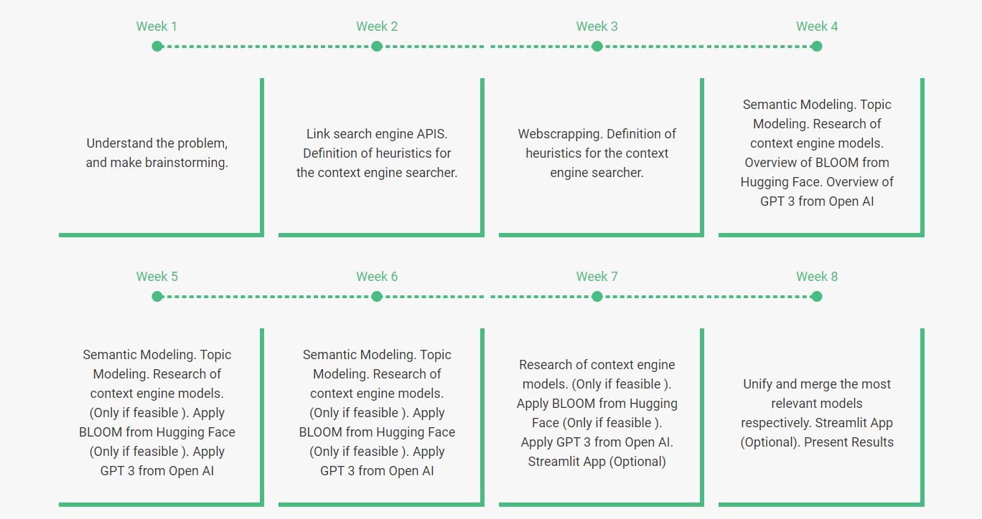

**Learning Outcomes**:

* Learn how to make connections with APIs of searching engines.
* Learn how to web scrap news and tweets.
* Learn how to do a topic modeling analysis.
* Learn what algorithms / models exist in the state of the art for the search or comparison of the context.
* Learn how a context engine works.

**Link**:

[News Veracity Validator in Latam - Phase 1 (omdena.com)](https://omdena.com/chapter-challenges/news-veracity-validator-in-latam-phase-1/)